***SQL TASK***

1. ***SELECT QUERIES***

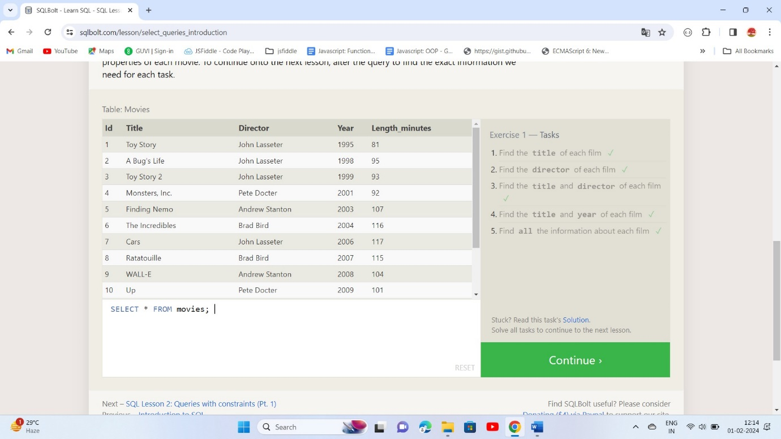

1. ***QUERIES WITH CONSTRAINTS (PT. 1)***

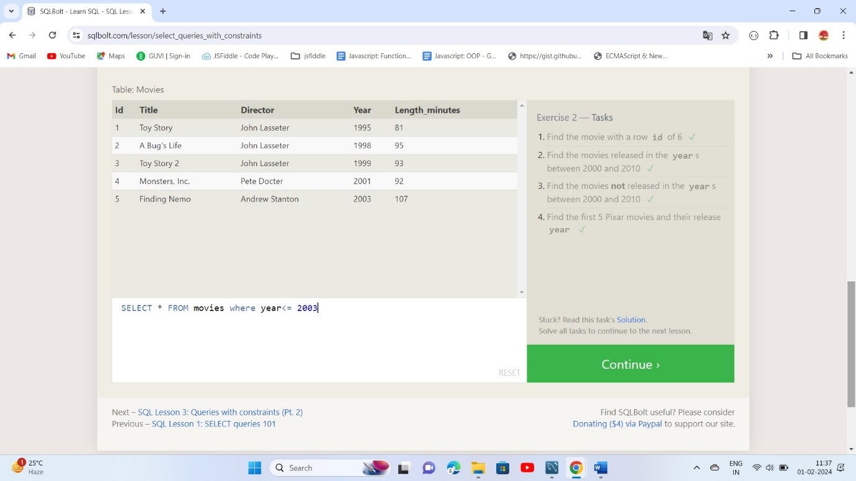

1. ***QUERIES WITH CONSTRAINTS (PT. 2)***

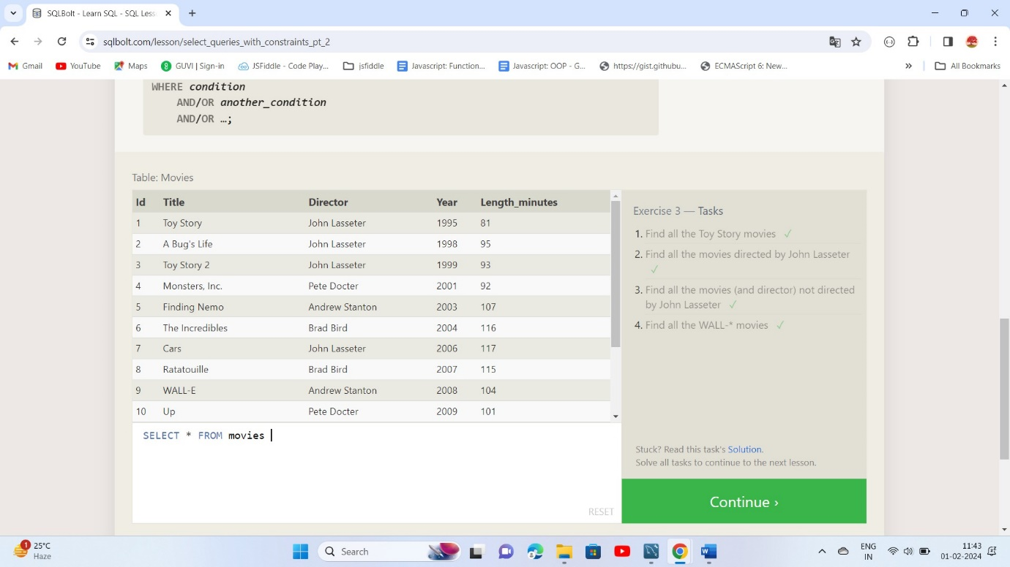

1. ***FILTERING AND SORTING QUERY RESULTS***

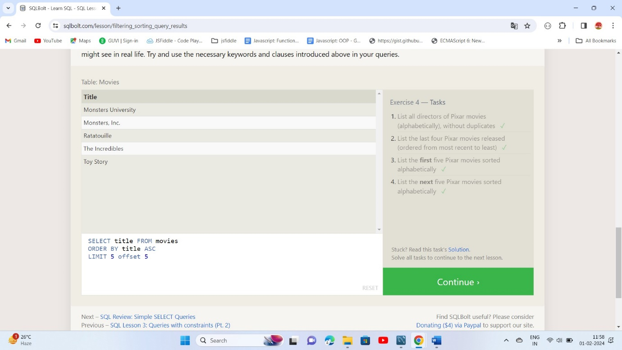

1. ***SIMPLE SELECT QUERIES***

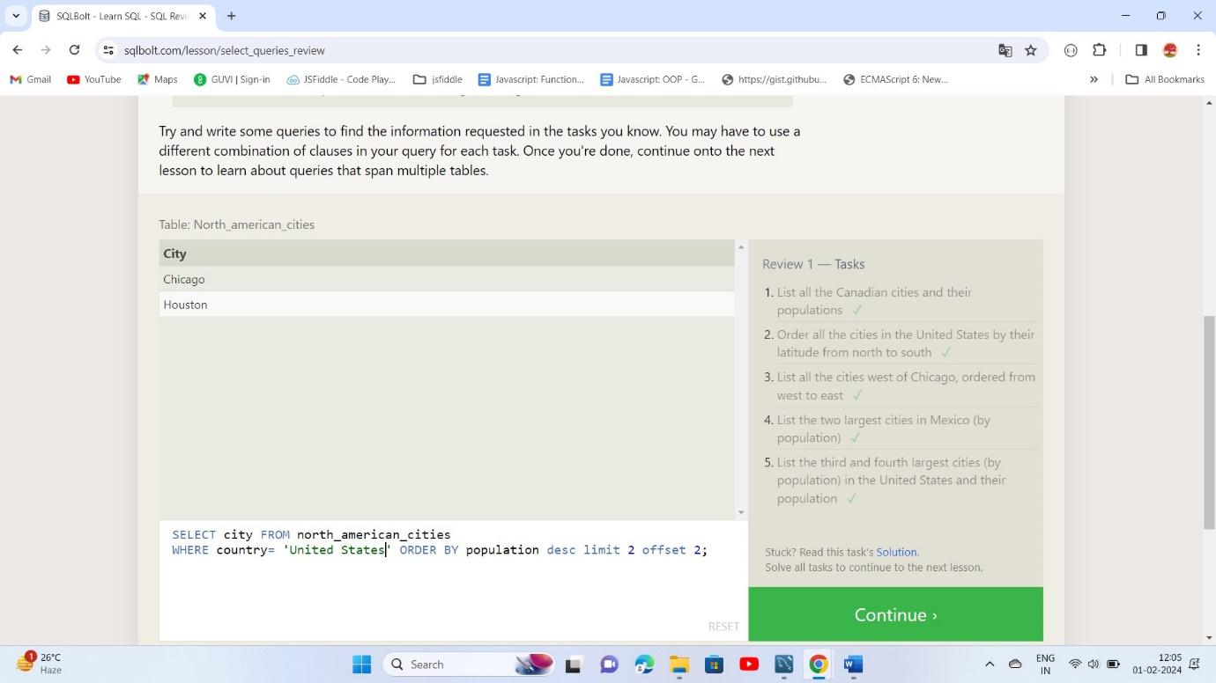

1. ***MULTI-TABLE QUERIES WITH JOINS***

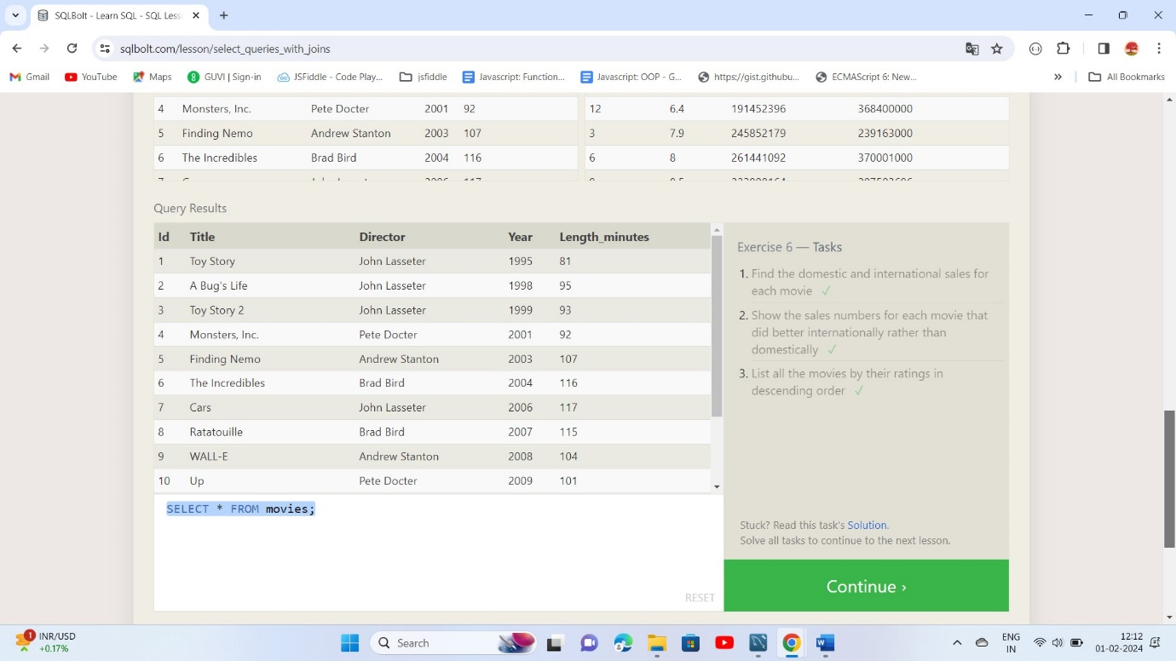

1. ***OUTER JOINS***

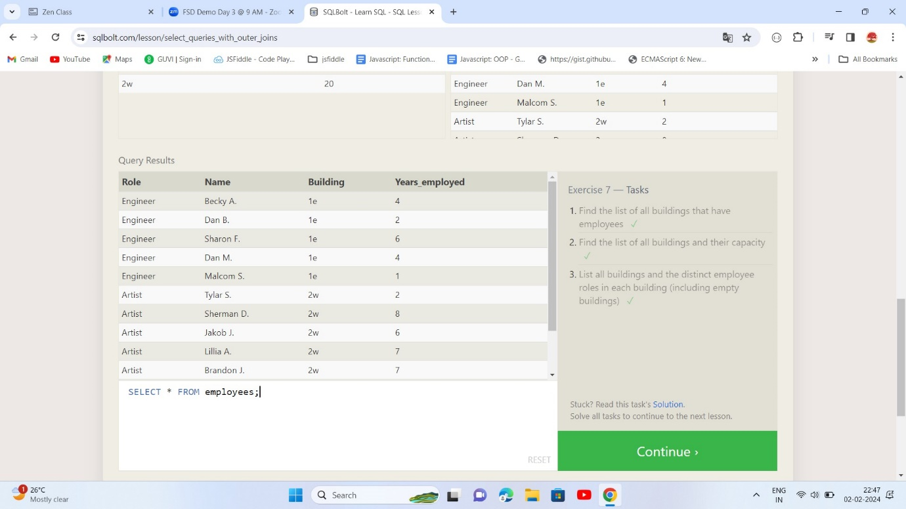

1. ***A SHORT NOTE ON NULLS***

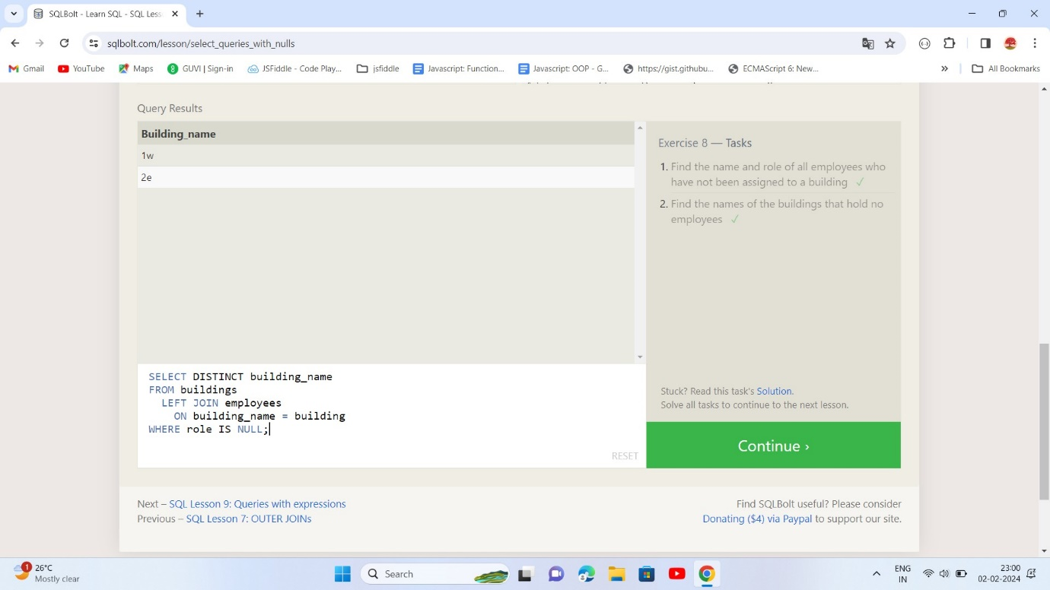

1. ***QUERIES WITH EXPRESSIONS***

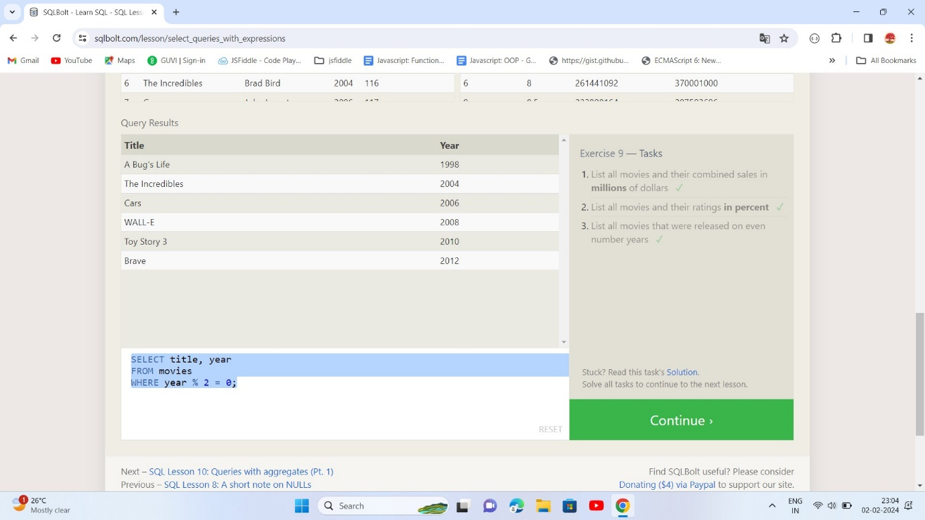

1. ***QUERIES WITH AGGREGATES (PT. 1)***

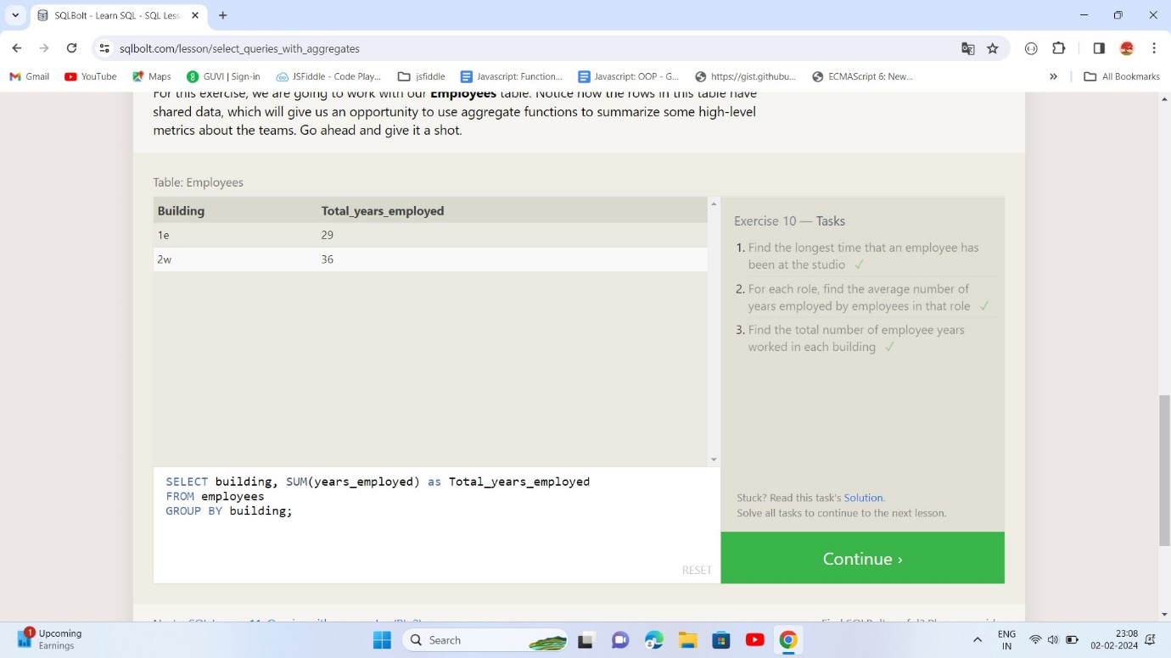

1. ***QUERIES WITH AGGREGATES (PT. 2)***

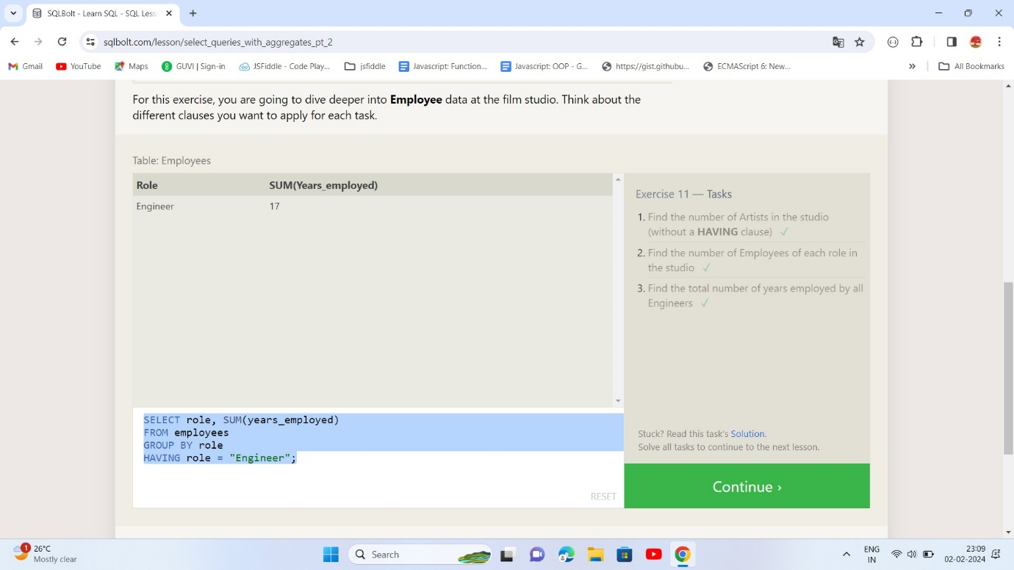

1. ***ORDER OF EXECUTION OF A QUERY***

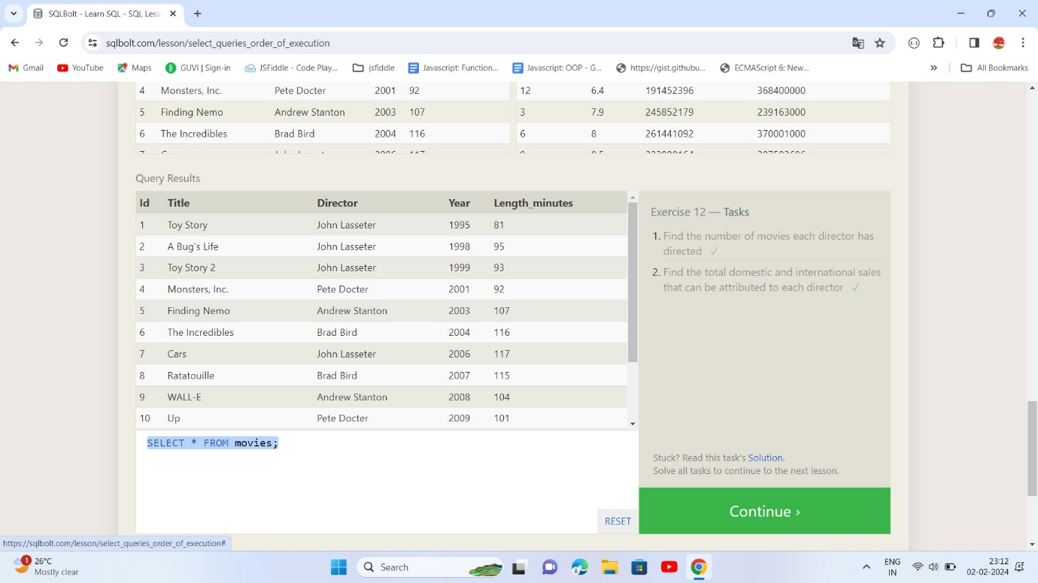

1. ***INSERTING ROWS***

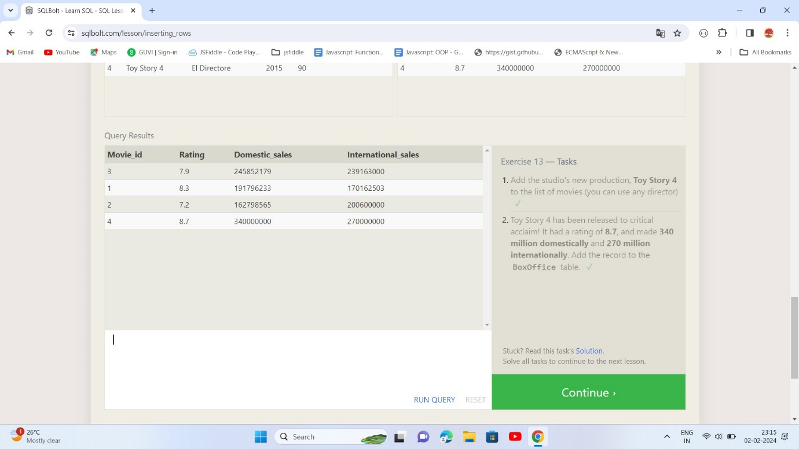

1. ***UPDATING ROWS***

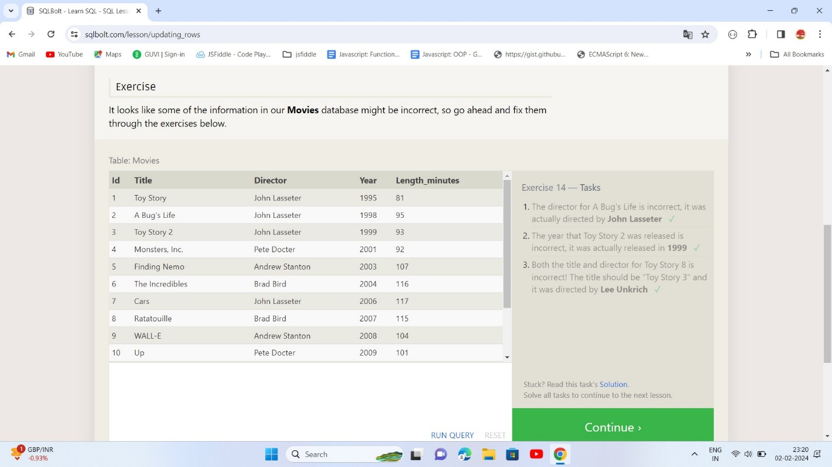

1. ***DELETING ROWS***

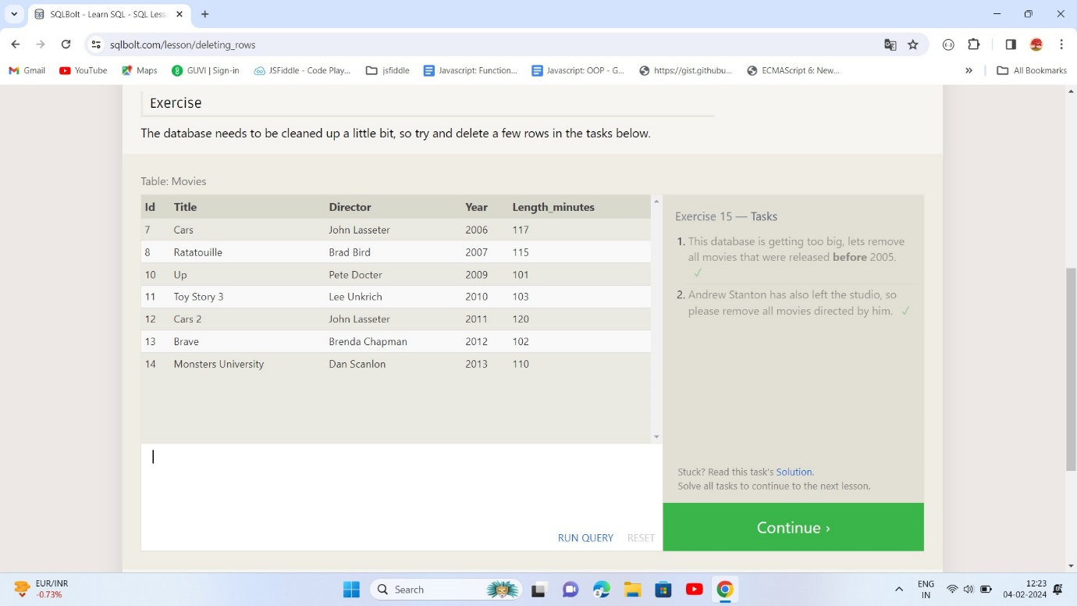

1. ***CREATING TABLES***

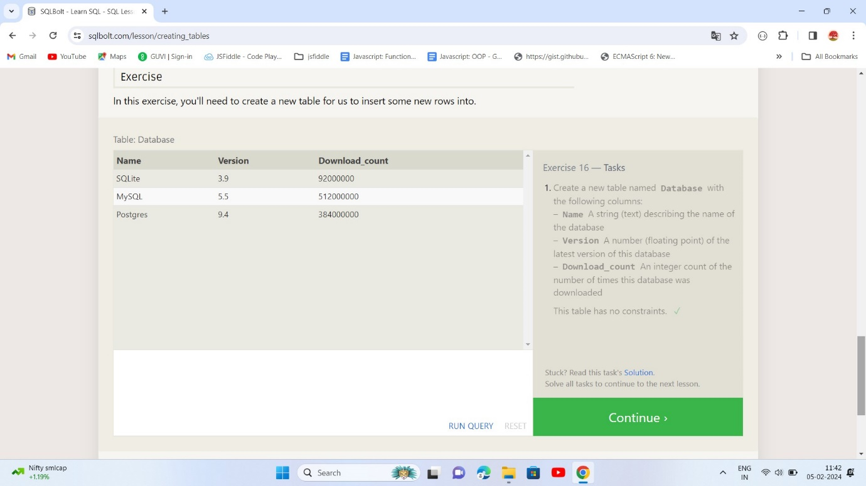

1. ***ALTERING TABLES***

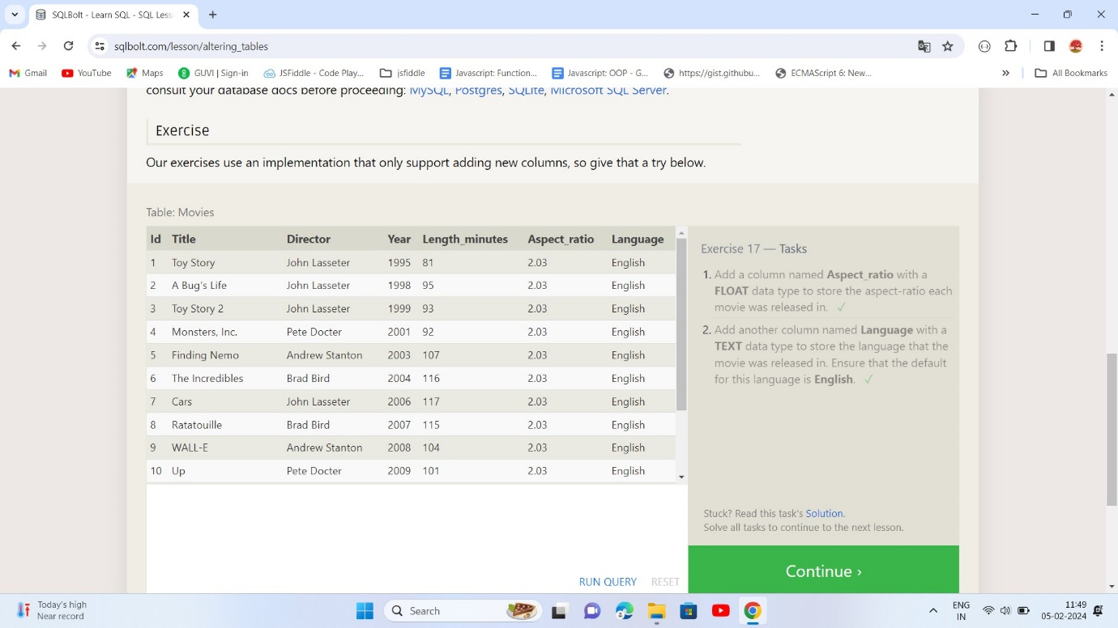

1. ***DROPPING TABLES***

